Sri Kalva | Chantilly, VA
Professional Experience Summary
Senior Systems, Cloud, and Solutions Architect with 20+ years of hands-on experience designing, migrating, securing, and operating large-scale on-premises, hybrid, and cloud-native platforms across commercial and federal environments. Deep expertise in AWS and Oracle Cloud Infrastructure, Kubernetes orchestration, DevOps automation, Infrastructure as Code, Python scripting for automating cloud provisioning, and mission-critical systems with high availability requirements. Proven leader in complex cloud migrations, performance tuning, security hardening, and CI/CD automation, supporting AI/ML workloads, enterprise ERP systems, and regulated government platforms.
Education & Certifications
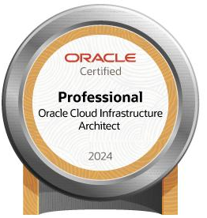
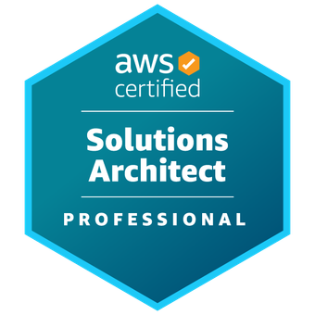

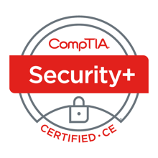
Master of Science in Computer Applications

Professional Experience
Sr. Integration/DevOps Engineer - 01/2025 – Present
- Design, deploy, and operate platforms using single-node and multi-node Kubernetes clusters, including highly available configurations with three master nodes and ten worker nodes supporting mission-critical workloads.
- Utilize Python scripting alongside shell-based automation to support operational tasks, validation workflows, environment checks, and automation efforts integrated with CI/CD pipelines and cloud infrastructure tooling.
- Architect and manage hybrid to include VMware vSphere virtualized platforms, and AWS EKS, ensuring resiliency, scalability, operational stability, and compliance with federal mission requirements.
- Implement Karpenter-driven node lifecycle management within AWS EKS to dynamically scale compute resources based on application performance demands, workload characteristics, and cost optimization objectives.
- Develop end-to-end DevOps automation pipelines leveraging Jenkins, Git-based repositories, and Ansible AWX to provision infrastructure, deploy applications, and manage supporting platform services at scale.
- Automate the provisioning, configuration, and lifecycle management of vSphere virtual machines using Infrastructure as Code and configuration management tools to ensure consistency, repeatability, and auditability.
- Maintain and harden Kubernetes clusters, operating systems, and supporting middleware through routine patching, vulnerability remediation, configuration baselining, and compliance enforcement activities.
- Collaborate closely with Information System Security Managers (ISSMs) to identify, prioritize, track, and mitigate cybersecurity risks across hybrid cloud and on-premises environments.
- Administer and integrate enterprise platform tooling including Rancher, OpenShift, Nexus, Containeryard, Foreman, and Zabbix to support cluster operations, monitoring, logging, and lifecycle management.
- Support PostgreSQL and MongoDB database platforms by ensuring availability, performance tuning, secure connectivity, and reliable integration with containerized and cloud-native application workloads.
- Lead operational sustainment activities by documenting system architectures, standard operating procedures, and troubleshooting methodologies to ensure long-term platform stability and supportability.
Sr. Architect / DevOps Automation Engineer – 06/2021 - 12/2024
- Served as senior technical subject matter expert responsible for architecting, deploying, and sustaining secure cloud-native and hybrid environments using Infrastructure as Code methodologies across enterprise platforms.
- Designed and implemented Terraform-based provisioning frameworks integrated with GitLab, Jenkins, and enterprise CI/CD pipelines to onboard new customer environments reliably and at scale.
- Delivered solutions across PaaS, SaaS, and hybrid architectures, integrating enterprise platforms such as Tanzu, Pega, Appian, and MarkLogic to meet diverse customer and mission requirements.
- Engineered secure customer onboarding workflows using AWS IAM, aligning identity management, access controls, and compliance requirements with enterprise governance and security standards.
- Developed and enforced secrets management and encryption strategies using AWS Secrets Manager and AWS KMS across multi-account and multi-environment cloud architectures.
- Integrated customer workloads into backend enterprise frameworks, ensuring compatibility with shared services, platform dependencies, and overarching security architectures.
- Collaborated within Agile delivery environments to implement incremental enhancements while maintaining platform stability, operational reliability, and continuous compliance.
- Designed network and security architectures incorporating Juniper vSRX and Big-IP F5 load balancers to support traffic management, fault tolerance, and high-availability requirements.
- Supported enterprise data platforms including Redshift, DynamoDB, Aurora, and OpenSearch, focusing on performance optimization, availability, scalability, and operational reliability.
- Produced detailed architecture documentation, operational runbooks, and SOPs to support transition to sustainment teams and long-term platform operations.

Sr. AWS Security Architect - 11/2020 – 12/2023
- Conducted cloud security engineering and threat hunting activities across large-scale AWS environments, supporting federal missions with stringent security, compliance, and audit requirements.
- Designed and implemented forensic analysis pipelines using AWS Athena and AWS SageMaker to perform large-scale log analytics, anomaly detection, and proactive threat identification.
- Built and maintained Infrastructure as Code (IaC) solutions using AWS CloudFormation and AWS native CI/CD services to deliver repeatable, auditable, and policy-compliant security deployments.
- Identified cloud misconfigurations and security vulnerabilities across multiple AWS accounts, providing actionable remediation guidance aligned with industry best practices and federal security standards.
- Collaborated with cross-functional stakeholders to harden AWS environments using IAM policies, centralized logging, continuous monitoring, and native security controls to reduce attack surface and risk exposure.

Cloud Migration, Solutions Architect, Systems DBA - 08/1997 – 10/2020
- Architected and led enterprise modernization and cloud migration initiatives, transitioning on-premises applications into Cloud Environments using lift-and-shift, rehosting, re-platforming, refactoring, and hybrid migration strategies.
- Designed and implemented secure, isolated cloud environments leveraging AWS VPC architectures and OCI networking constructs to support mission-critical, multi-tier enterprise workloads across heterogeneous platforms.
- Led end-to-end infrastructure planning, system design, security configuration, and migration execution, ensuring solutions aligned with performance, availability, resiliency, and regulatory compliance requirements.
- Developed and maintained Infrastructure as Code (IaC) solutions using AWS CloudFormation to deliver repeatable, auditable, scalable, and consistently governed cloud deployments.
- Engineered automated CI/CD pipelines utilizing CodePipeline, CodeCommit, CodeBuild, and CodeDeploy to support continuous integration, testing, validation, and deployment of migrated enterprise applications.
- Performed comprehensive application and infrastructure fit-gap analyses, delivering customized and bolt-on solutions for legacy systems and unsupported platforms during large-scale cloud transition efforts.
- Planned and executed complex cutover and migration activities, including pre-go-live simulations, rollback strategies, and coordinated production releases to minimize downtime and operational risk.
- Conducted performance tuning, capacity planning, and database upgrades, applying horizontal and vertical scaling models to optimize reliability, throughput, and efficiency of cloud-hosted systems.
- Designed and implemented high-availability and resiliency architectures to support mission-critical workloads with strict uptime, recovery time, and disaster recovery requirements.
- Authored detailed technical architecture documentation, SOPs, and operational runbooks to support effective knowledge transfer, operational readiness, and long-term sustainment by support teams.

